

**INDIAN INSTITUTE OF INFORMATION TECHNOLOGY, ALLAHABAD VI Semester B.Tech in Information Technology Report - Group Assignment 2**

Data Mining and Warehousing

**Deep Support Vector Data Description for Unsupervised and Semi-Supervised Anomaly Detection**

**By :-**

Palak Mittal (IIT2018117)

Nehal Singh (IIT2018119)

Abhishek Kumar Gupta (IIT2018187)

Puja Kumari (IIT2018191)

Prabha Kumari (IIT2018195)

1. INTRODUCTION:

Anomaly detection (AD) is the task of identifying unusual samples in data, which raise suspicion by differing significantly from the majority of the data. An unsupervised approach would ignore this valuable information. A fully supervised approach to AD, on the other hand, learns to separate the anomalies from the normal data. Semi-supervised approaches aim to bridge the gap between supervised and unsupervised AD. These approaches do not assume some common pattern among the “anomaly class” and thus do not impose the typical cluster assumption semi-supervised classifiers build upon.Instead, semi-supervised approaches to AD aim to find a “compact description” while still correctly classifying the labeled data. Through this, semi-supervised AD methods do not overfit to the labeled anomalies and generalize to novel anomalies.

1. PROPOSED PROBLEM :

In this problem we have to detect anomalies on high-dimensional data. We have proposed the method Semi-Supervised Deep Support Vector Data Description (SS-DSVDD). We demonstrated experimentally, that SS-DSVDD significantly improves detection performance with only small amounts of labeled data. Our results suggest that semi-supervised approaches to AD should be preferred in applications where some labeled information is available.

1. ALGORITHM:
   * First of all, We minimize the volume of a data-enclosing hypersphere with radius R > 0 using neural network transformation, then we optimize the network weight W such that most of the data falls within the hypersphere center.
   * After that, normal points get closely mapped to the hypersphere center, whereas anomalies are mapped further away or outside the sphere.
   * Then,using the One-class SS-DSVDD,we impose a quadratic loss on the distances of the mapped points to the fixed center c, for both the unlabeled samples and the labeled normal points. For the labeled anomalies, we penalize the inverse such that anomalies must be mapped further away from the center.
2. RESULT :

**ROC SCORES FOR EACH CLASSES WERE:**

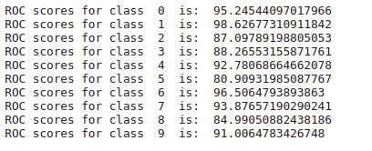

Outliers V/S inliers for each class :

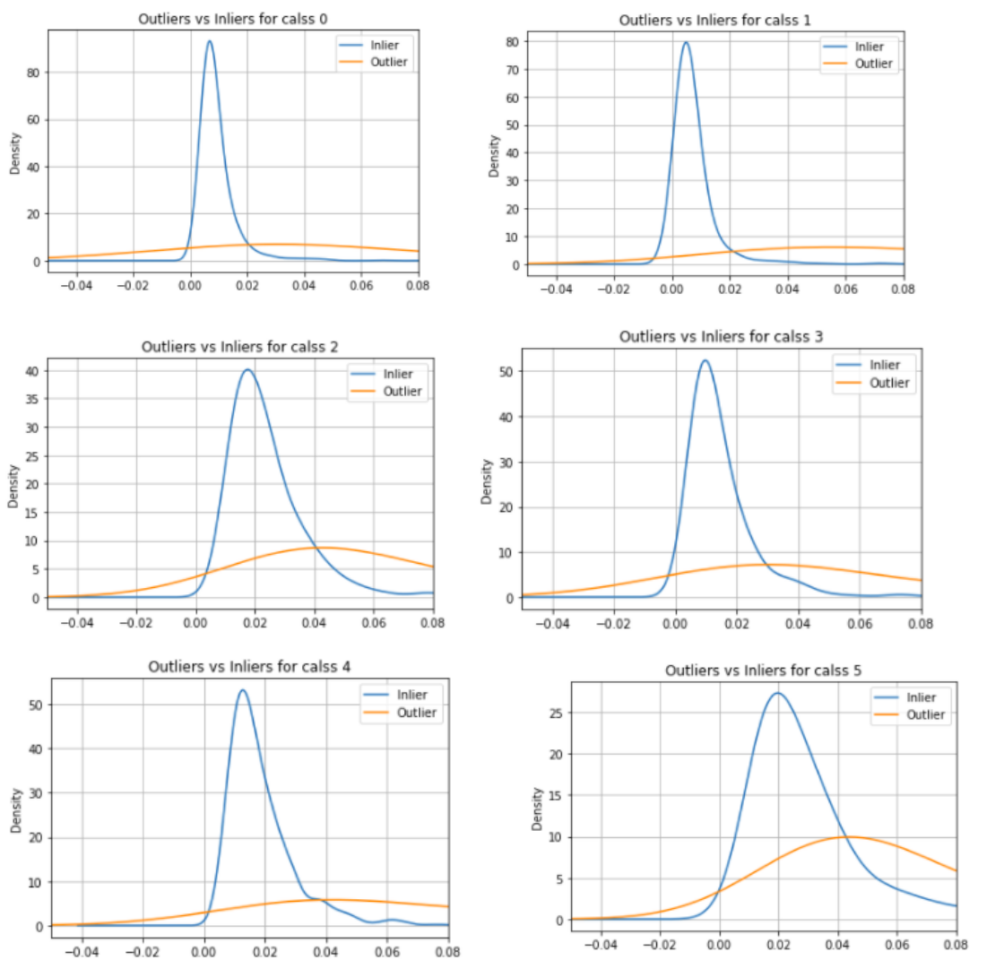

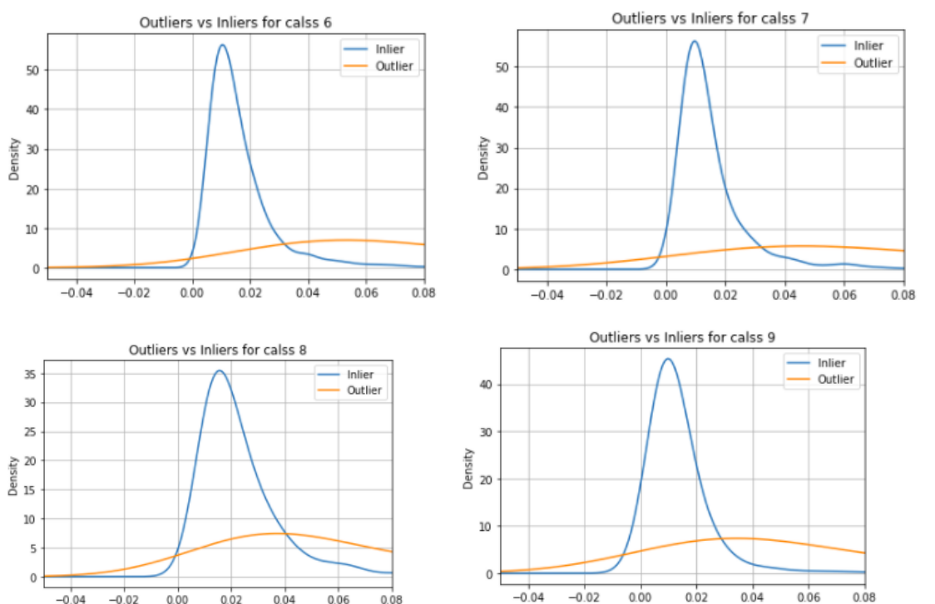

According to this experiment , The Deep Support Vector Data Description for Unsupervised and Semi-Supervised Anomaly Detection (IMPLEMENTED) showed better/similar performance as compared to Paper.

5. CONCLUSION:

We see that the performance of the supervised approach is very sensitive to the number of anomaly classes, but since the number of anomaly classes is limited in our setups, the classifier catches up at some point. In comparison to the supervised classifier, which is vulnerable to novel anomalies at testing, our semi-supervised method generalizes well to novel anomalies.Our results suggest that semi-supervised approaches to AD should be preferred in applications where some labeled information is available.

